ORDINANCE No.__553_____, AMENDING THE ZONING ORDINANCE OF THE VILLAGE OF ROMEO, MACOMB COUNTY, MICHIGAN

AN ORDINANCE TO ESTABLISH RULES AND STANDARDS FOR THE CONSTRUCTION, LOCATION, MAINTENANCE AND REMOVAL OF ALL SIGNS IN THE VILLAGE OF ROMEO, EXCEPT THOSE SIGNS EXEMPTED FROM REGULATION BY THIS AMENDATORY ORDINANCE OR OTHER ORDINANCES OF THE VILLAGE OF ROMEO. THE PURPOSE OF THIS AMENDATORY ORDINANCE IS TO PROTECT THE INTERESTS OF PUBLIC HEALTH, SAFETY AND WELFARE AND TO ENSURE THE MAINTENANCE OF AN ATTRACTIVE PHYSICAL ENVIRONMENT WHILE SATISFYING THE NEEDS OF SIGN USERS FOR ADEQUATE IDENTIFICATION AND COMNMUNICATION.

THE VILLAGE OF ROMEO ORDAINS:

Section_______Objectives.

- General – Ensure that signs are located, designed, constructed, installed, and maintained in a way that protects life, health, morals, property and the public welfare.

- Public Safety – Protect public safety by prohibiting signs that are structurally unsafe or poorly maintained; cause unsafe traffic conditions because they unreasonably distract motorists, have similarities to official traffic signs or hinder vision; and impede safe movement of pedestrians or safe ingress and egress from buildings or sites.

- Protect Aesthetic Quality of Districts and Neighborhoods – Prevent blight and protect aesthetic qualities by preventing visual clutter and protecting views. Prevent proliferation of signs in residential areas and eliminate abandoned signs and sign structures on unused properties. Also, avoid glare, light trespass, and sky glow through selection of proper fixture type(s) and location, lighting technology, and control of light levels. Additionally, reflect the character of unique districts as may be established by the Village’s Master Plan, other adopted plans or the zoning ordinance.

- Free Speech – Ensure that the constitutionally guaranteed right of free speech is protected and allow signs as a means of communication.

- Business Identification – Allow for adequate signage for business identification and other commercial speech, non-commercial speech, and dissemination of public information, including but not limited to, public safety information and notification as may be required by law.

- Foster Economic Development – Ensure that signs are located in a manner that does not cause visual clutter, blight, and distraction, but rather promotes identification and communication necessary for sustaining and expanding economic development in the Village.

- Recognize Unique Areas – Acknowledge the unique character of certain districts, and establish special time, place and manner regulations that reflect the unique aesthetic, historical, and/or cultural characteristics of these areas.

Section______. Definitions. For the purposes of this Ordinance, the following words shall have the associated definitions ascribed to them. Words not defined shall be given their common and ordinary meaning.

- Abandoned Sign – A sign that remains in place and continues to advertise a business, service, owner, product, or activity that has ceased operations or has closed for thirty (30) days or more, or pertains to a time, event, or purpose which no longer applies.

- Attached Sign – Any sign affixed to, applied on, or supported by any part of a building located on premise.

- Awning Sign – A permanent sign that is directly applied, attached, or painted onto an awning, which is a projection, shelter, or structure of canvas, metal, wood, or other similar approved material that covers a pedestrian walkway and is intended for protection from the weather or as a decorative architectural feature.

- Banner Sign – A temporary attached sign having characters, letters, or illustrations applied to plastic, cloth, canvas, or other light fabric, with the only purpose of such non-rigid material being for background.

- Billboard Sign – A large freestanding sign, generally supported by a metal frame, and consisting of two (2) parallel sign faces which are oriented in opposite directions, used for the display of posters, printed, or painted advertisements that generally directs attention to a location other than the premise on which the sign is located.

- Changeable Electronic Message/Reader Board Component or Sign – A permanent sign or portion of a permanent sign designed to allow advertising or wording to be changed at periodic intervals, either manually or electronically, and is operated whereby light is turned on and off intermittently.

- Commercial Center – A commercial building comprised of multiple, individual businesses on a single lot where the primary entrance for each tenant is generally accessed from the outside.

- Façade – Any separate face of a building, including parapet walls and omitted wall lines, or any part of a building which encloses or covers usable space. Where separate faces are oriented in the same direction, or in directions within forty-five (45) degrees of one another, they are to be considered as part of a single façade.

- Flag – A piece of fabric attached to a staff or cord on one (1) end and generally used as a symbol of a nation, state, political subdivision, or organization.

- Flagpole – A freestanding device permanently placed in the ground for the purpose of flying a flag of a nation, state, political subdivision, or organization.

- Government/Regulatory Sign – A sign for the control of traffic or for identification purposes, street signs, warning signs, railroad crossing signs, and signs of public utility and service companies indicating danger or construction, which are erected by or upon the order of a public officer, employee or agent thereof, in the discharge of official duties.

- Ground Sign – A permanent freestanding sign that is supported from grade to the bottom of the sign, having or appearing to have a solid and opaque base independent of the principle building or structure, and is generally used to identify the name of a business and/or development on the property.

- Inflatable Sign – A temporary sign manufactured of plastic, cloth, canvas, or other light fabric and inflated with air.

- Mechanical Sign – Any sign, which rotates, shakes, or moves by means of a motor, battery, or the like.

- Nonconforming Sign – A sign and its supporting structure which do not conform to all or part of the provisions of this Ordinance.

- Pole Sign – A freestanding sign, which is constructed on a vertical framework consisting of one (1) or more upright supports, secured in the ground.

- Portable Sign – Any sign not permanently attached to the ground or to a building, which is designed to be easily transported or conveyed to different locations. This term includes, but is not limited to, signs on wheels or affixed to trailers or skids, tent signs, sandwich board (A-frame) signs, T-shaped signs, airborne signs, and similar devices.

- Projecting Sign – A permanent attached sign that is wholly or partially dependent upon a building for support and extends more than twelve inches (12”) from said building, generally at a right angle.

- Revolving Sign – A sign that turns, spins, partially revolves, or completely revolves 360 degrees on an axis.

- Roof Sign – A sign mounted on and supported by the roof portion of a building, above the uppermost edge of a parapet wall and is supported by the building, or a sign that is painted directly upon the roof or top of a building.

- Sandwich Board (A-frame) Sign – A portable sign consisting of two (2) panels of equal size, which are hinged at the top and placed on the ground or pavement so as to be self-supporting.

- Sign – Any form of communication which directs attention to an individual, business, commodity, service, activity, or product, by means of words, figures, numerals, emblems, devices, trade names, or trademarks, or other pictorial matter that communicates information of any kind to the public.

- Sign Area – The area of the sign that is utilized for the display of information to include background, however, does not include the framework or base of the sign.

- Variance – An official authorization from the Village of Romeo Zoning Board of Appeals used to allow exceptions to regulations or requirements of this Ordinance.

- Vehicular Sign – A sign painted upon or applied directly to (including magnetic) any truck, car, bus, trailer, boat, recreational vehicle, motorcycle, or other vehicle. Vehicular signs shall exclude bumper stickers, license plates, and inspection and registration stickers.

- Wall Sign – A permanent sign affixed to or painted on an exterior wall and extending not more than twelve inches (12”) from the façade of any building to which it is attached, supported throughout its entire length by the building face.

- Wind Device – Any pennant flag, streamer, spinner, balloon, feather sign, or similar device made of cloth, canvas, plastic, or any flexible material designed to float or move freely.

- Window Sign – A sign affixed to any surface of a window (internal or external) or is located within three feet (3’) from the interior window of any establishment.

Section_______. Prohibited Signs. The following signs are prohibited in the Village of Romeo:

- Signs designed to flutter or move, except when permitted as a temporary sign.

- Signs which are flashing, animated, or moving, or have scrolling messages.

- Balloon signs and/or inflatable signs, except when permitted as a temporary sign.

- Signs attached to utility poles, streetlamps, or other similar structures.

- Signs, except those established and maintained by the village, county, state, or federal government, that are located in, project into, or overhang a public right-of-way, or dedicated public easement, except projecting or awning signs permitted within the Central Business District. No such projection shall exceed three (3) feet nor shall a sign or awning be placed over a road surface.

- Sign which project over the roof.

- Sign which restrict free ingress or egress from any door, window, or fire escape, or prevent proper ventilation.

- Signs which simulate or imitate in size, color, lettering, or design any traffic sign or signal, phrase, symbol, or character in such manner as to interfere with, mislead, confuse, or create a visual impediment or safety hazard to pedestrian or vehicular traffic.

- Unlawful motor vehicle signs. It shall be unlawful to park, place, or store a vehicle or trailer on which there is a motor vehicle sign on private property if:

a. Such vehicle is allowed to remain parked in the same location or in the same vicinity, at frequent or extended periods of time, where the intent is apparent to be one of using the vehicle and signs for purposes of advertising an establishment, service, or product.

b. The motor vehicle sign is attached to a vehicle or trailer that is unregistered or not operable.

c. The motor vehicle sign is larger in any dimension than or extends beyond any surface of the vehicle or trailer to which it is attached.

d. The motor vehicle sign is attached to a vehicle or trailer that is parked or stored in a public right-of-way or an area not designed, designated, or commonly used for parking.

e. The motor vehicle sign is attached to a vehicle or trailer that is regularly parked or stored in a "front yard" or "side yard," as such terms are defined in the zoning ordinance.

f. The motor vehicle sign is attached to a vehicle or trailer that is regularly parked or stored within fifty (50) feet of a street, when there are other areas of the property designed, designated, or available for the parking or storage of the vehicle or trailer that are more distant from the street or not visible from the street.

g. The foregoing prohibition shall not apply if the vehicle is temporarily parked in a particular location in the course of conducting person or business activities that involves the loading or unloading of goods for customers, providing services to off-site customers, conducting off-site business, or engaging in work breaks.

Section______. Signs Not Requiring a Permit. A permit shall not be required for the following types of sign.

- Freestanding non-illuminated temporary signs not exceeding twelve (12) square feet in area.

- Signs not visible from a public right-of-way, public park, or residentially zoned property.

- Window signs in nonresidential areas, which occupy no more than thirty (30) percent of the total window area.

- Sign erected by or on behalf of or pursuant to the authorization of a public government body, including but not limited to legal notices, informational signs, directional, and regulatory signs.

- Signs indicating handicapped accessibility, not exceeding four (4) square feet.

- Markers, plaques, or signs describing a state or national designation as a historic site or structure, including historic home plates.

- Directional signs not exceeding two (2) square feet in sign area for each sign.

Section______. Signs Requiring a Permit. A permit shall be required for the following types of sign.

- Temporary signs exceeding twelve (12) square feet in area.

- Wall signs

- Ground Signs

- Pole signs

- Banner signs

- Hanging signs

- Projecting Signs

- Awning signs

- Portable Sandwich Board Signs

- Relocation or increase in size of any sign listed above.

Section______. General Sign Requirements. The following regulations shall apply, unless otherwise specifically stated in this Ordinance, to all signs erected or located in any zoning district within the Village.

- Sign Permitting and Content – All signs are subject to the general and specific regulations of this Ordinance whether they require a permit or not.

- Any sign permitted under this Ordinance may contain either a commercial or noncommercial message.

- No sign, except those established and maintained by governmental units, shall be located in, project into or overhang a public right of way, or dedicated public easement unless otherwise expressly permitted herein.

- Location in Front Yard – Ground and pylon signs may be located in the required front yard, except that in no case shall they be located closer than ten (10) feet to any property line, and it shall meet the following standards:

- The visibility of pedestrians and vehicles are in no way impaired.

- The sign does not encroach in a clear vision corner triangle of twenty (20) feet, measured along the abutting road right-of-way and driveway to the site.

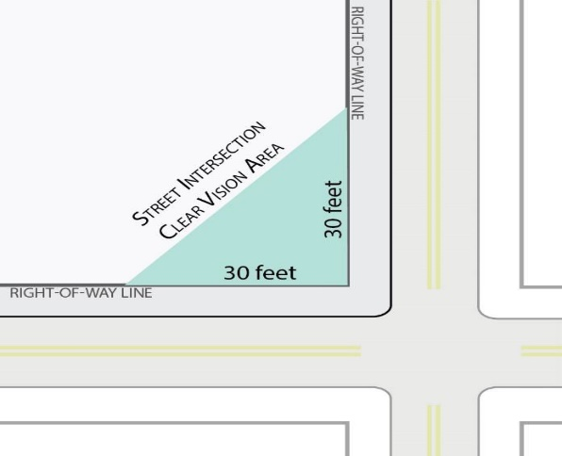
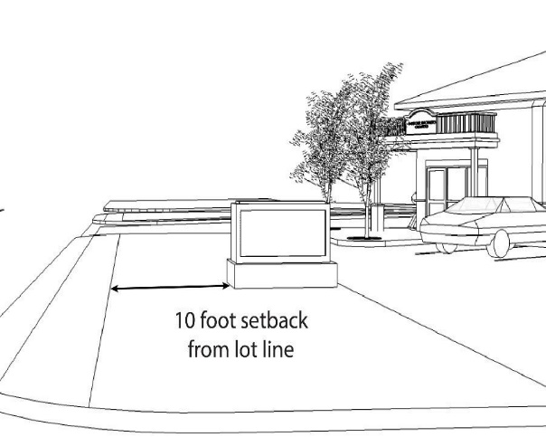
20 Feet
20 Feet

Sign Clear Vision Area

A minimum sign setback of ten (10) feet is required from the property lines for all ground and pole signs
A twenty (20) foot clear vision area is required at street and driveway intersections

- Measurement of Sign Area

- For permanent signs, sign area shall constitute the entire area within a rectangle or the sum of rectangles enclosing the extreme limits of writing, representation, emblem, or any figure of similar character, or of any internally illuminated area.

- Sign height shall be measured from the top edge of the sign and/or support structure. If a sign is located on a mound, berm, or other raised area for the sole purpose of increasing the height of the sign, the height of the mound, berm, or other raised area shall be included in the height of the sign.

Sign Area

Pole Sign

Sign Height
Sign Area

Sign Height
Monument Sign

Guidelines for Computing Sign Height and Area

- Where a sign has two (2) or more faces, the area of all faces shall be included in determining the area of the sign, except that where two (2) such faces are placed back to back and are at no point more than three (3) feet from one another, the area of the sign shall be taken as the area of one face if the two (2) faces are of equal area, or as the area of the larger face if the two (2) faces are of unequal area.

- Illumination

- Illuminated signs shall not be of the flashing or intermittent type.

- The source of illumination may be internal or external. The source of the light shall not be exposed except for the lighting that is integral for the use of an electronic sign.

- External sources of illumination shall be shielded and directed to prevent glare onto public rights-of-way or neighboring properties.

- Maintenance of Signs

- All signs shall be maintained in good structural condition, in compliance with all building and electrical codes, and in conformance with this Ordinance.

- A sign shall not have weeds, trees, vines, or other vegetation growing upon it, or obscuring the view of the sign from the public right-of-way.

- Awning Signs – Awnings with signage and those that are illuminated shall be regulated as a wall sign. All illumination shall be confined to that portion of the awning used for signage purposes. Awnings in a shopping center or office complex shall be uniform or complementary in color. No awning shall extend into any required yard setback, with the exception of the Central Business District, in which it may project up to eight (8) feet. All awnings shall be maintained in good condition. Torn or damaged awnings shall be removed or repaired by the owner of the site. Awning shall have a minimum of eight (8) feet of clearance from the lowest point of the sign to the ground or grade level.

- Temporary Signs – Because of a unique character of certain signs which are intended for use on a less than permanent basis and because of the effect of such signs on surrounding properties and persons, temporary signs shall be permitted only for a specific time period. All temporary signs shall observe the following standards:

- No temporary sign shall exceed a maximum area of 24 square feet or exceed a maximum height of six feet.

- All temporary signs shall observe the setback requirements contained in this Ordinance.

- Temporary signs shall be permitted for a period of no longer than 15 days. Signs may be renewed for one 15-day period. No parcel may be allowed more than two temporary signs in any 12-month period.

- The sign shall be installed in a manner so as not to impose a hazard to pedestrians or vehicular traffic, persons or property.

- Inflatable signs may be allowed, provided that they observe all other applicable standards of this Ordinance.

- An application for a temporary sign shall be filed by an applicant as provided by the Village. The Village Clerk shall review the application for a temporary sign and, if the sign complies with all applicable requirements of this section, shall approve the application and direct the issuance of a permit for such sign. No person shall display or cause to be displayed a sign enumerated in this section without a permit.

- Portable Signs – Portable sidewalk or "A-frame" signs are allowed in the Village, provided that each such sign has met the requirements of this section. All portable signs shall conform to the following standards:

- The sign shall be of A-frame construction with a minimum base spread of 18 inches; not more than 24 inches wide; and not more than 36 inches high. The sign shall be sturdy and stable.

- The sign shall not have more than two faces and the surfaces of the sign shall be durable.

- Copy on the sign may be painted or printed on the surface or surfaces. Loose paper faces shall not be permitted. The sign shall not be illuminated by any means except natural light and existing street lighting.

- Placement of the sign shall be in a manner that is safe for and does not interfere with pedestrian or vehicular traffic. Placement of the sign shall be coordinated with other signs, benches, trees, planters and other streetscape elements such that a minimum of five feet of unobstructed sidewalk shall be maintained at all points along the sidewalk for pedestrian use.

- Only one sign is permitted for each permanent address of a building. A business with its only entrance door on a pedestrian alleyway may place one sign per pedestrian alley only at the curb edge along the street on which the building faces. All businesses in a building that have their only entrance door on a pedestrian alleyway shall share a single sign by listing the businesses on one sign, or by alternating usage of the sign at different times.

- A sign may be placed outside only during the hours when a business is open to the general public and shall be stored indoors, out of sight, at all other times.

- An application for a portable sign shall be filed by an applicant as provided by the Village. The Village Clerk shall review the application for a portable sign and, if the sign complies with all applicable requirements of this section, shall approve the application and direct the issuance of a permit for such sign. No person shall display or cause to be displayed a sign enumerated in this subsection without a permit.

- The sign application shall show a drawing of the front and side of the sign and shall include the dimensions of the sign and a plan of the sidewalk area and intended sign placement, all of which shall show compliance with the provisions of this Section.

- The owner of the sign and the owner of the site upon which it is located shall sign a statement assuming all liability for damage and injury that may be caused by the sign and releasing and indemnifying the Village from and against any and all claims for liability or damages that may be caused by the sign. If requested by the village, the owner of the sign and the owner of the site upon which the sign is located must provide the Village with proof of insurance against liability and damages in an amount and manner acceptable to the Village.

- Wall Mounted Signs – Wall signs mounted on a building shall not project more than twelve (12) inches horizontal beyond the wall of the building, unless otherwise provided for in this Chapter. A wall sign shall only be allowed on the principal front of the building.

- Reader or Changeable Boards – Freestanding signs for office, commercial, and industrial establishments may include a non-scrolling or non-flashing reader board to be calculated as part of the overall allowable signage area.

- Addresses – Addresses shall be visible and legible from the public right-of-way.

Section______. Sign Regulations by Zoning District.

- Residential Districts

- Freestanding non-illuminated temporary signs not exceeding twelve (12) square feet in area.

- Residential development signs may be allowed at the principal street entrance to any development in all residential zoning districts, subject to the following standards:

- Entrance signs or structures shall be located outside of any right-of-way and clear vision intersection.

- No more than two entrance signs shall be permitted. Such signs or structures shall not exceed twenty four (24) square feet per sign. No more than one sign may be placed on each side of an entranceway or in an entrance road median.

- Institutional uses such as schools, churches, libraries and similar uses shall be permitted one freestanding and/or one wall sign, which shall not exceed a total area of thirty-two (32) square feet.

- Central Business District

- Freestanding non-illuminated temporary signs not exceeding twelve (12) square feet in area.

- Each business may be allowed not more than one wall sign on each entrance side of the business. The total sign area shall not exceed one square foot for each lineal foot of building frontage, or fifty (50) square feet whichever is less.

- In lieu of a wall sign, an individual business occupying a separate parcel may place a projecting sign perpendicular to the face of the building. The maximum area of the projecting sign shall not exceed nine square feet.

- A business may be permitted one wall, and one projecting sign or freestanding sign, where possible, provided that the total combined sign area shall not exceed one square foot for each lineal foot of building frontage, or fifty (50) square feet whichever is less.

- Office Districts

- Freestanding non-illuminated temporary signs not exceeding twelve (12) square feet in area.

- An individual business occupying its own site may be allowed one wall and one ground or monument sign. The maximum sign area shall not exceed thirty two (32) square feet. The maximum height of the sign shall not exceed six (6) feet.

- All ground signs shall observe a minimum front yard setback at least ten (10) feet from the property line or right-of-way.

- Ground signs shall not have internal lighting, but may have directed lights. They may be constructed of brick, metal, wood, or similar durable materials.

- General Commercial Districts and Industrial Districts

- Freestanding non-illuminated temporary signs not exceeding twelve (12) square feet in area.

- Each individual business occupying its own site shall be regulated as follows:

- One (1) ground sign and one (1) wall sign shall be permitted.

- One (1) additional ground sign shall be permitted if such development abuts two (2) major or secondary thoroughfares.

- Ground signs shall be limited to one hundred fifty (150) square feet in area, and ten (10) feet in height.

- Wall signs shall be limited to two (2) square feet of building width at the front building line, or eighty (80) square feet, whichever is less.

- Any parcel of land occupied by two (2) or more businesses shall be regulated as follows:

- One (1) ground sign shall be permitted.

- One (1) additional ground sign may be permitted if the development abuts two (2) major or secondary thoroughfares.

- Ground signs shall be limited to one hundred fifty (150) square feet in area, and ten (10) feet in height.

- Each business within the development, having separate and direct access to the exterior of the building and not from an entrance in common with other businesses, shall be permitted one (1) wall sign.

- Wall signs shall be limited to two (2) square feet of tenant space width at the front building line, or eighty (80) square feet, whichever is less.

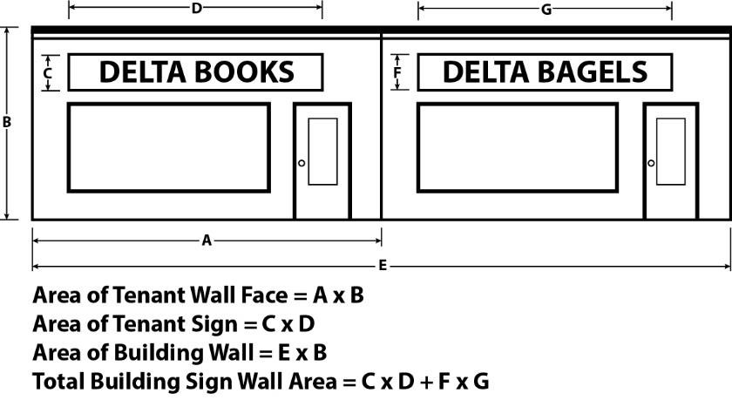
  - ROMEO BOOKS
  - ROMEO BAGELS

30’

Example: Maximum Allowable Area of Wall Sign
30 x 2 sq. ft. = 60 square feet

Section______. Permits. A permit is required from the Village Building Department for any new and modified signs unless the requirement for a permit is specifically exempted by this Ordinance. Each permit shall be issued in accordance with the following:

- Application – Written applications for sign permits shall be made on forms provided by the Village. All applications for sign approval shall be accompanied by the following information:

- The name and address of the property owner. If the applicant is not the property owner, the signature of the property owner shall be provided.

- An accurate scaled drawing of the property showing the location of all buildings, structures, or lots tow which the sign is to be attached or erected, showing other existing signs, property lines, and the location of the sign.

- A drawing of the proposed sign to be erected or installed on the site, including the following detailed information:

- Height of the sign above the ground.

- Surface of the sign (material, color, and dimensions).

- Area of the sign surface.

- Lettering of the sign drawn as it will appear on the erected sign.

- Method and color of illumination, if any.

- Logos, emblems, or additional features.

- Such information as the Village Clerk deems necessary and/or pertinent to the application.

- Approval or Disapproval of Application – Upon receipt of all necessary submissions required by this subsection, the Village Clerk shall review the application for conformity with the requirements of this chapter. The Village Clerk shall either approve or disapprove the application within five (5) business days. If the application is approved by the Village Clerk, it shall then be reviewed by the Building Inspector for conformity with the Village building codes, and, if in compliance therewith, the building inspector shall issue a permit. A permit issued under this subsection shall not be assigned or transferred in any manner whatsoever if the sign covered by the permit is to be altered in any way.

- Suspension or Revocation – A sign permit may be suspended or revoked whenever any of the following occurs:

- Any provision of this Ordinance is being violated.

- Any condition of the permit is not being observed.

- It is necessary to preserve or protect public health, safety, or welfare.

- Non-transferable – No sign for which a permit has been issued hereunder shall thereafter be moved to another location with the Village, nor shall it be structurally altered in any way without the approval of the building official. An additional fee shall be paid at the time of application for permission to move or alter such sign.

Section_____. Nonconforming Signs. All existing signs that do not conform to the provisions of this Ordinance shall be permitted to continue as nonconforming signs until removed or altered, at which time they shall conform to the provisions. Nonconforming signs shall be subject to the following:

- Good Working Order – Nonconforming signs shall be maintained with all necessary structural and decorative parts, including but not limited to supports, sign frame, and electrical equipment. All sign copy areas shall be intact, and illuminated signs shall be capable of immediate illumination.

- Servicing – Painting, servicing, cleaning or minor repairs to a nonconforming sign shall be permitted.

- Alterations – Alterations to nonconforming signs shall be prohibited, except as follows:

- The sign copy area of a nonconforming sign may be altered, including replacement of sign panels and changes to the sign copy, provided that the degree of nonconformity is not increased.

- Alterations to the sign frame or structural elements of a nonconforming sign shall be permitted, only when the sign shall be brought into compliance with the maximum sign height and sign area standards for the location and type of sign, as specified in this Ordinance.

Section______. Exceptions. Exceptions to this Ordinance may be permitted by the Zoning Board of Appeals upon the following affirmative findings:

- That the request is based upon circumstances or features that are exceptional and unique to the property, and that are not self-created.

- That the failure to grant relief will result in substantially more than mere inconvenience or financial expenditures.

- That strict application of the regulations of this Ordinance will unreasonably prevent or limit the use of the property, or will unreasonably preclude the visibility or identification of a building on the property.

- That the requested variance will not result in a sign or condition that is incompatible with or unreasonably interferes with adjacent or surrounding properties, and is not inconsistent with the spirit and intent of this Chapter.

Section______. Repealer. All ordinances or resolutions, or parts thereof, in conflict with the provisions of this Ordinance are, to the extent of such conflict, repealed.

Section______. Severability. If any portion or section of this Ordinance is for any reason held to be invalid or unconstitutional by a court of competent jurisdiction, the invalidity or unconstitutionality of such section, paragraph, clause or provision shall not affect any of the remaining provisions of this Ordinance and they shall remain valid and enforceable.

Section______. Effective Date. This Ordinance shall be effective upon its publication as provided in MCL 66.1 and MCL 66.4.

ADOPTION OF THE AFORESAID ORDINANCE:

MOVED BY:___________________________

SUPPORTED BY:________________________

YEAS:________________________________

NAYS:________________________________

MADE, PASSED AND ADOPTED BY THE ROMEO VILLAGE COUNCIL ON THIS__________DAY OF MAY, 2020.

____________________________
CHRISTINE MALZAHN
Romeo Village President

A complete copy of this Ordinance is on file and available for public inspection at the Village of Romeo Office, 121 W. St. Clair Street, Romeo, Michigan 48065, during regular business hours, 8:30 a.m. to 4:30 p.m., Monday through Friday, excluding legal holidays.

CERTIFICATE OF ADOPTION OF ORDINANCE

I hereby certify that the foregoing is a true copy of Ordinance No._______, Amending the Zoning Ordinance of the Village of Romeo, Macomb County, Michigan, passed at the regular meeting of the Romeo Village Council held on the ________day of May, 2020.

____________________________
KATHRYN TRAPP
Romeo Village Clerk

Publish:______________________, 2020

